Alfa tech India Manual Paneer cutter:
Type: Manual Mechanical Screw Type
Manual Paneer Cutter
Cutting size : 200 gm, 400 gm, 500 gm & 1 kg (Customizable cutting grid)
Material : Blades Stainless steel 304
Frame Structure : Heavy duty SS 304
Rulon food grade cutting base
Paneer block size : 300 mm x 300 mm x 100 mm Manual Operation
Pressing Plate: Removable SS slotted grid plate for proper whey drainage.
Base Plate: Food Grade HDPE/ Rulon cutting Board( removable & washable)
Drain System: Open Grid design for easy whey flow & cleaning.
Finish: Mirror/Mat SS Finish (Good grade)
Block Size: 200gm, 400gm, 500gm, 1kg (Customized available)
Paneer Mould
Capacity : 7 KG
Material : Stainless Steel
Timing : 10- 15 Mins
Heavy Duty Machine
Used for : Panner, chesse, shrikhand, etc.

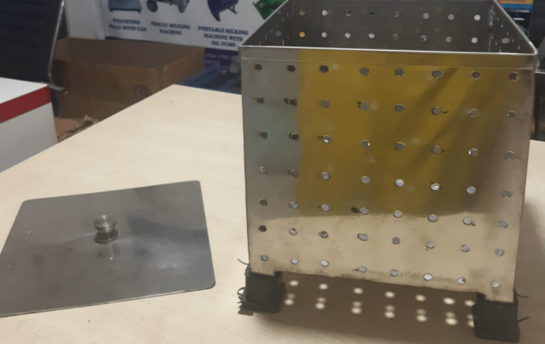

Mecahnial Screw Type Paneer Press:
Capacity : 7- 10 KG
Material : Stainless Steel
Timing : 10- 15 Mins
Heavy Duty Machine
Used for : Panner, chesse, shrikhand, etc.

